- Tự tìm hiểu về IP fragment (ví dụ: https://www.youtube.com/watch?v=DgcbVsGIYfE ) và làm bài tập sau:
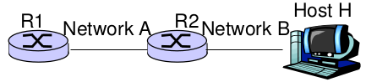
- Giả sử MTU là 1500 bytes cho network A và 532 bytes cho network B
- Giả sử R1 nhận 1 IP packet (gọi là packet P) và cần chuyển tới H. Biết rằng gói packet chứa 2000 bytes TCP segment [ TCP header + data]
- Giả sử 20 bytes cho IP header
Cho biết:
- giá trị M bit (More Fragment) và Offset field cho những IP fragment của packet P gửi từ R1 trên network A
- IP fragment 1:
+ More fragment: 1
+ Offset field: 0 ( no fragmented data )
- Ip fragment 2:
+ More fragment: 0
+ Offset field: 185 ( bytes per fragment = MTU – IP header = 1480, offset of fragment = 1480 / 8 = 185)
- Tương tự cho những packets gửi từ R2 trên network B
The same to network A:
- IP fragment 1:
+ More fragment: 1
+ Offset field:
- IP fragment 2:
+ More Fragment: 1
+ Offset field: 64.
-IP fragment 3:
+ More Fragment: 1.
+ Offset field: 128.
- IP fragment 4:
+ More Fragment: 0.
+ Offset field: 192

- Tất cả các fragments có giá trị identifier field giống nhau và giống với packet P?
- Đúng vậy, vì trường nhận dạng (identification field) được dùng để xác định 1 gói tin IPv4 cụ thể. Giá trị này được dùng để ghép các mảnh đã được tách ra cảu gói tin. Vì thế, trường nhận dạng ( identification field) phải giống nhau cho tất cả các gói và giống cùng với tin gốc.
-
- Cho một bảng routing table của một router R
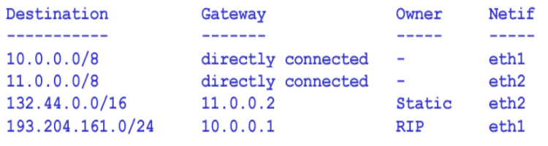
Hãy đưa ra một network topology mà tương thích với routing table ở trên

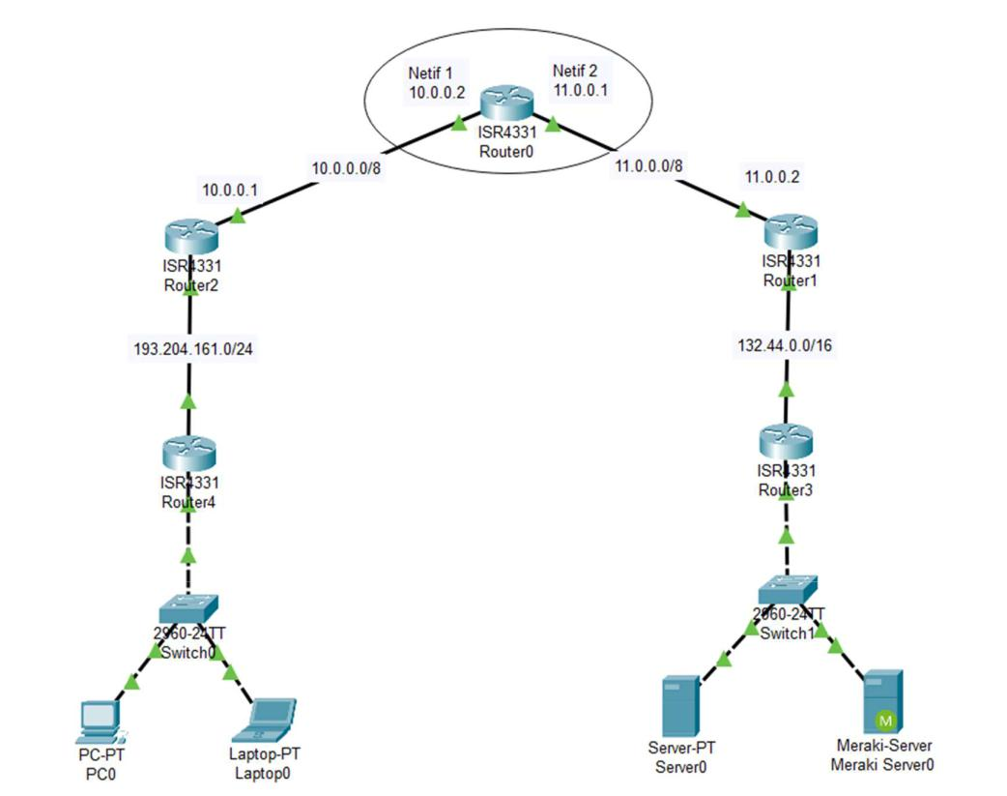

- NAT

Consider the scenario below in which three hosts, with private IP addresses 10.0.1.14, 10.0.1.17, 10.0.1.20 are in a local network behind a NAT'd router that sits between these three hosts and the larger Internet. IP datagrams being sent from, or destined to, these three hosts must pass through this NAT router. The router’s interface on the LAN side has IP address 10.0.1.27, while the router’s address on the Internet side has IP address 135.122.204.214

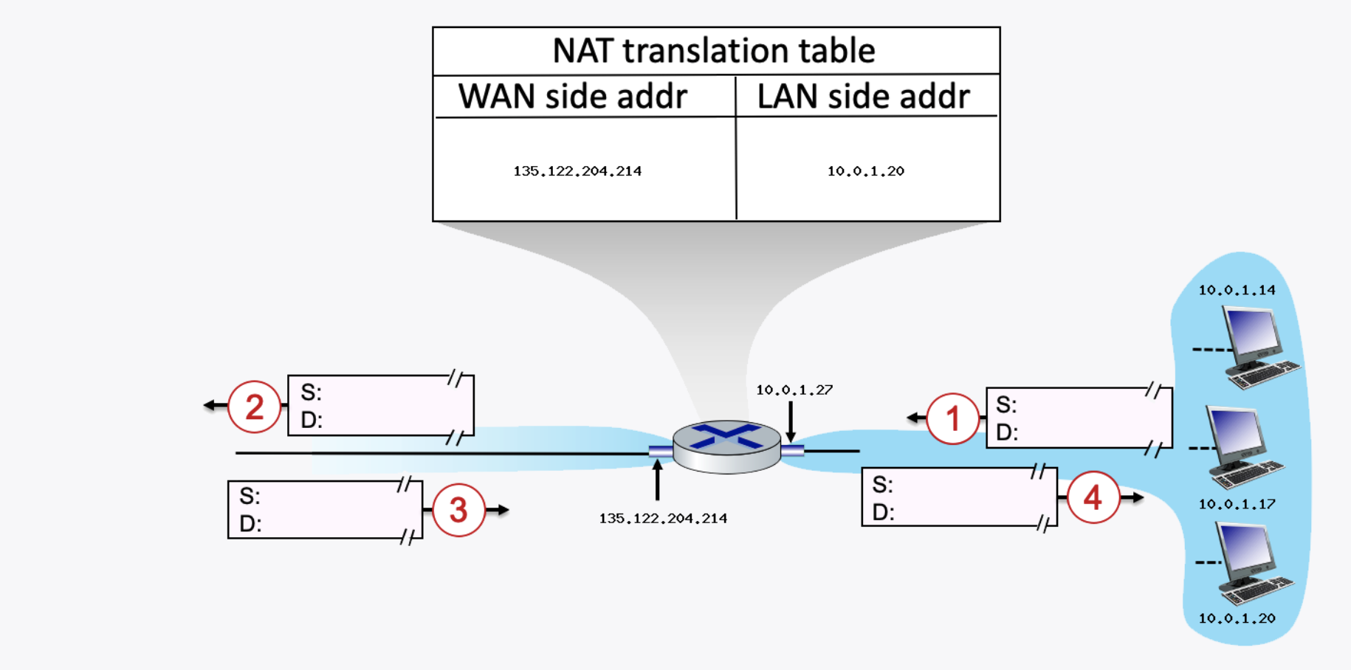

Suppose that the host with IP address 10.0.1.20 sends an IP datagram destined to host 128.119.172.183. The source port is 3370, and the destination port is 80.

QUESTION LIST

1. Consider the datagram at step 1, after it has been sent by the host but before it has reached the router. What is the source IP address for this datagram?
- Source IP address: 10.0.1.20
2. At step 1, what is the destination IP address?20
- Destination IP address: 128.119.172.183
3. Now consider the datagram at step 2, after it has been transmitted by the router. What is the source IP address for this datagram?
- Source IP address: 135.122.204.214
4. At step 2, what is the destination IP address for this datagram?
- Destination IP address: 128.119.172.183
5. Will the source port have changed? Yes or No.
- Yes
6. Now consider the datagram at step 3, just before it is received by the router. What is the source IP address for this datagram?Yes
- Source IP address: 128.119.172.183
7. At step 3, what is the destination IP address for this datagram?
- Destination IP address: 135.122.204.214
8. Last, consider the datagram at step 4, after it has been transmitted by the router but before it has been received by the host. What is the source IP address for this datagram?
- Source IP address: 128.119.172.183
9. At step 4, what is the destination IP address for this datagram
- Destination IP address: 10.0.1.20

